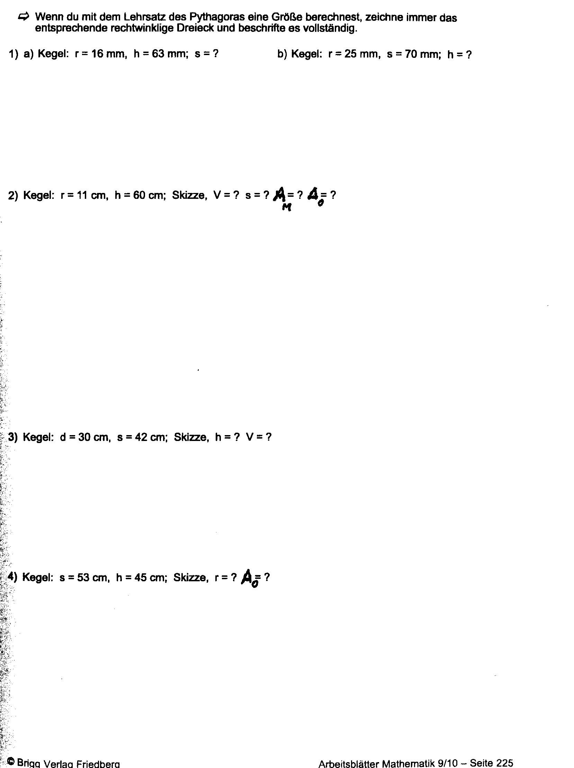
r=28cm
A_{o}=7‬.125,1321383416510648332751932779‬‬cm²

h=39cm
V=‬9.189,1585117501452225032318960928‬cm²

S=61cm
V=7.602,6542216872996370795969875366‬cm²
A_{M}=2.108,0086705587512630084337101805‬cm²
A_{o}=2.488,1413816431162448624135595574‬cm²
S=65mm h=65mm

